Compréhension écrite | Health in Glasgow
Correction
Réponses aux questions – sauf pour les mots de vocabulaire que vous devez chercher vous-mêmes
Glasgow is known as the city where the life expectancy is 65 years old – this is the lowest rate in the whole of Britain.
Glasgow’s obesity rate is among(st) the highest in the world.
One in five workers can potentially benefit from incapacity benefits [allocation invalidité].
Premature deaths are most of the time triggered [trigger = déclencher]by four things: drugs, alcohol, suicide and violence.
Those factors started to appear / emerge in the 1990s.
The segment (part) of the population that is the most likely to [susceptible de] suffer from these health issues [problèmes de santé] are people (men and women) aged between 15 and 45.
Walter Brown was an alcoholic. He suffered from seizures [malaises liés à l’alcool], temporary paralysis and cirrhosis of the liver.
Mr. Brown’s doctor [GP = médecin généraliste] told him that if he drank another litre of alcohol, he would probably have severe brain damage [toujours au singulier] or eventually die.
There are many reasons put forward to try to explain this sad ‘glasgow effect’.
- Some people think that it is because of the cold and rainy weather which may cause ‘chronic vitamin D deficiency’.
- Others blame Margaret Thatcher because she shut down industries in the city in the 1980s – this led to a high rate of unemployment.
- Other people think that sectarianism between Catholics and Protestants could be responsible for this.

Protestants in Glasgow (Church of Scotland) | Roman Catholics in Glasgow
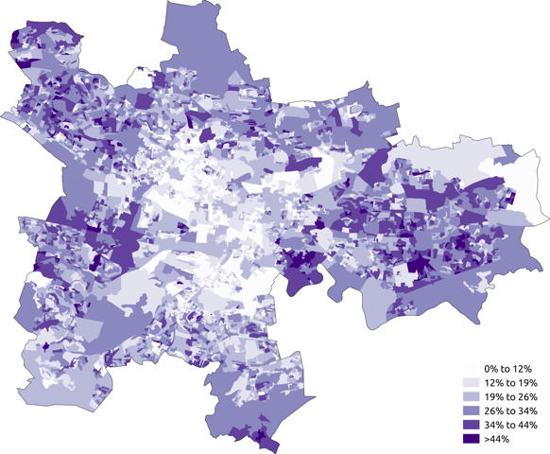 | 